THE KENNEL CLUB GOOD CITIZEN DOG SCHEME –

BRONZE AWARD ONLY

Between 10.30pm-3pm
ENTRY is £5.00 per dog

all entries must register by 12.30pm to be allocated a time slot
For details, please contact Debbie Buck 07720 345464 or email debbie.buck@bernese.co.uk

Please make sure you have any equipment needed with you.
The details of what is required can be found on the Kennel Club website:- https://www.thekennelclub.org.uk/dog-training/good-citizen-dog-training-scheme/taking-part-in-the-good-citizen-dog-training-scheme/

CHARACTER ASSESSMENTS

The cost per dog is £10.00
THE CLUB'S CODE OF ETHICS ENCOURAGES MEMBERS
TO HAVE THEIR BREEDING DOGS ASSESSED

Why not take the opportunity and have it done today? Certificates and rosettes are awarded to all who pass & your dog's name will appear in the next club publication as proof of the result.

To pass “EXCELLENT” your dog must achieve an excellent in all tests; to achieve a “PASS” grade your dog must not fail in any exercise. The tests are not designed to frighten your dog but merely to show how he/she copes with normal everyday situations such as crowds of people, coping with traffic, being close to other dogs or if he/she encounters something unusual such as a shopping trolley passing by or a sudden noise.

A maximum of 10 dogs can be assessed on the day therefore it is necessary to book in advance by contacting Debbie Buck on 07720 345464- by 28th April please - Bitches in season cannot take part. Dogs must be over 12 months of age on the day. If not fully subscribed by Bernese, other breeds may be assessed but priority WILL be given to Bernese, if fully subscribed please ask to be placed on the reserve list

ALL DOGS ENTERED MUST REGISTER AT THE TABLE NO LATER
THAN 10.30am PROMPT IN ORDER TO BOOK A TIME SLOT.

BERNESE MOUNTAIN DOG CLUB OF GREAT BRITAIN


SPRING GARDEN PARTY
SUNDAY 3rd May, 2026

Hollowell Steam Rally Field
Teeton Road
Guilsborough Northamptonshire
NN6 8RB
Disabled parking & Camping ///What3Words – porridge.butternut.venue
General parking ///What3Words – financial.outer.grading

The Spring Garden Party will be held at the Hollowell Steam Rally Field.
This event is for every Bernese & their owners.
Come along to meet friends old & new.
All dogs are more than welcome.
Learn about our breed & enjoy a fabulous day out
having lots of fun with your dogs.
*********************************************************
There will be lots of activities throughout the day including 2 decorated carting classes:-
Swiss Theme, & Best Carting Turnout as well as the Carting Fancy Dress–
the theme this time is “The Adam’s Family”.
Party games for all including the ever popular Markies & spoon race. There will be biscuit catching & musical sits, (Fab Rosettes for “Overall Champion Biscuit Catcher” &
Champion Fastest Musical Sits,) so start practicing now!
Novelty classes such as the Prettiest Bitch, Most Handsome Dog & the Best Bad Hair Day!
Shed a tear or two & be proud at our fabulous Bernese parades for the Golden Oldies - 7 years and over, as well as the Rescue Parade for all Bernese Rescue dogs.
You can melt at the sight of the puppies in the puppy parade & we are also repeating the hugely popular “We R Family” parade - where we see litter siblings & closely related dogs all getting to know each other and having fun.
For those of you who like to work your dogs, there will be obedience & agility classes & also a chance to show off the working roots of the Bernese in the working cart classes.

The BernerShop will be there for you to spend all your pennies with a wonderful range of Bernese gifts, clothes & books etc.

Camping available on site - see separate leaflet
or contact Lianne Marsden for more details 07977 686455 or email lianne.marsden@bernese.co.uk

Breed information talks for people new to our breed or anyone wishing to add a Bernese to their family – what to look for, what to ask, what to avoid – all the questions you have answered by experienced Bernese owners
Except where otherwise stated,
entry fee is £5.00 per dog – you can enter any number of classes
Main Ring Programme of events from 10.00 a.m.:-.
Novelty classes ( 2 – 16) will be judged by Owen Copeland
The events in the Main ring will be judged and run in the following order (but will be interrupted by the timed events listed below.) Listen to announcements for any changes.
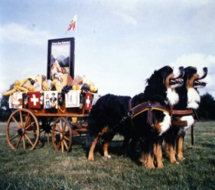
10.00 a.m.
Class 1 - Decorated Carts based on a Swiss Theme
Judged by Michelle Barsby
Class 2 Most Handsome Dog
Class 3 Prettiest bitch.
Class 4 Dog with the most appealing eyes.
Approx 11.00am Puppy Parade.
Class 5 Best Smile
Class 6 Waggiest Tail
Class 7 Cutest Dog
Class 8 Dog most like it’s owner

Approx 12 noon - Rescue Parade
For any rescued or rehomed BMD’s —please fill in information form & bring to the ring. Entry is free & all parading dogs receive a rosette
CARTING DEMO- from First Draft to Advanced Carter – what’s it all about? Chris, Di & their team will be demonstrating over the lunch period to show you how to turn your Bernese beginner into an advanced carter
FUN AND GAMES
Knock out heats for
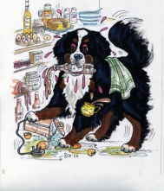
Biscuit catching - Markie and spoon race - Fastest Sitter and more!
Approx 1.00pm— Golden Oldies Parade
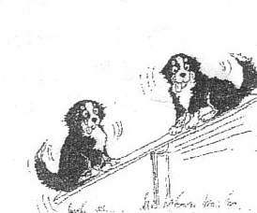
for all Bernese aged 7 years and over.
Please fill in information form and bring to the ring.
Entry is free and all parading dogs receive a rosette.
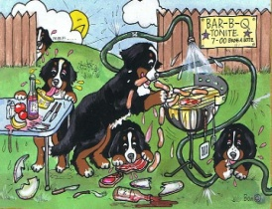
Class 9 - Decorated Carts—Fancy Dress –“The Adam’s Family”.

Class 10 Junior Handling 6-10 years
Class 11 Junior Handling 11-16 years
Class 12 Best Bad Hair Day (dog or human!)
Class 13 Best Condition
Class 14 Best Brace or Trio (of dogs!)
Class 15 Best Trick
Class 16 Best Hello – Paw shake or cuddle!

Approx 3.00pm—“We R Family” Parade
for litter mates and/or dogs closely related.

Presentation of awards for Obedience, Agility, First Draft & Carting
Ring 2 10.00 start
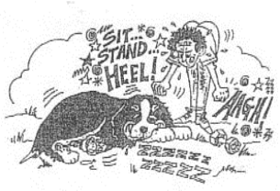
Obedience – Judge: TBC
OBEDIENCE – Have a go for Bernese. - Dogs not to have won more than 2 x 1st or 2nd places at any BMDC of GB obedience competitions. Heel on lead, Recall on lead, Sit 30 seconds, Down 1 minute both on lead.
OBEDIENCE -Trier's - Bernese that have not had 4 or more 1st or 2nd in ANY BMDC of GB obedience competition. Heel on lead, Heel free, Recall off lead, sit 1 minute, down 1minute.
OBEDIENCE - Future stars Open to ALL BERNESE. Heel free (normal & slow pace), “A” Recall, retrieve any article, sit 1 minute, down 2minutes.
OBEDIENCE – Open. For all Non BMD and abilities. Heel free (normal & slow pace), “A” recall, Retrieve any article, sit 1 min, down 2 mins.
*************************************************************
Agility - Judge – Ray Burke
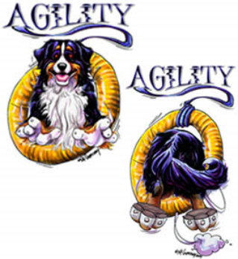
Please do not use the agility equipment without supervision
During the morning there will be the opportunity to practice.
Timed runs will be 1.00pm – 3.30pm
AGILITY-BEGINNERS - BMD ONLY - dog must not have won more than 2 x 1st or 2nd places at any BMDC of GB club event
AGILITY ALL BREEDS – not BMD For any breed and ability
AGILITY-NOVICE - BMD ONLY - Open to all.
*************************************************************
Working Cart Ring. 9.30am prompt– Judges: Chris Handley, Di Crawshaw & Elaine Spalding
Dogs may enter ONE class only.
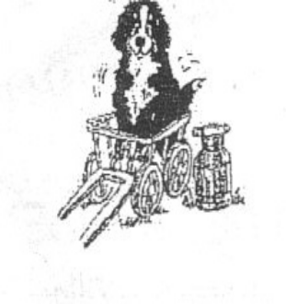

9.30am -11.30am CARTING - BEGINNERS
12 noon -1.00pm CARTING - INTERMEDIATE
1.30pm - 2.30pm CARTING - ADVANCED
3.30pm - 4.00pm CARTING - MEDALS ADVANCED
Anytime CARTING – VETERAN

CARTING COURSE WILL CLOSE AT 4.00pm PROMPT
Working cart entrants must register with the steward. All dogs must start at the beginners class & only proceed to the Intermediate class when they have achieved 90% of available marks at 3 Bernese carting competitions & have been awarded the beginners carting certificate. Dogs that have previously been awarded the Beginners or Intermediate carting certificates may compete in Intermediate or Advanced classes as appropriate. Those with 3 or more passes at Advanced level will still compete in the Advanced class. A list of all previous scores & a table showing which class each dog is eligible for will be available in the carting ring.
Please try to adhere to the above times for the carting classes.

Carting First Draft as well as First Draft Practice will be available
to do on Saturday & Sunday of the weekend

